**Title: - "Enhancing Netflix's User Engagement and Content Success"**

**Audience:**

We have been commissioned by Netflix to analyze their extensive content dataset. The primary audience for this report is the Netflix content strategy team, which includes data analysts, content managers, and marketing strategists. Their access to data ranges from basic to sophisticated. Therefore, the visualizations and explanations will be detailed but communicated without overuse of technical terms. The dataset contains a range of variables, including types of content, release years, genres, ratings, and geographic availability. This data spans multiple years and reflects both movies and TV shows available on the platform.

**Questions Needed to Be Answered:**

1. How has the volume of content added to Netflix varied over the years, and what does this indicate about Netflix's market strategy and content acquisition efforts?
2. What genres are most prevalent on Netflix and how do these align with user engagement and subscription retention rates?
3. Which content ratings are most common among Netflix's offerings, and how does this distribution cater to the target audience demographics?
4. How does the geographical distribution of content reflect upon Netflix's international expansion and localization strategies?
5. How have content ratings trends shifted over the years and how does this diversity in content types of influence viewing habits and content consumption patterns?

**Information about the Data:**

The goal of the Tableau project was to improve Netflix's user engagement and content success by analyzing large amounts of data using the Netflix Titles Dataset.[[here]](https://github.com/DataScienceRoadMapDSRM/Tableau-Dashboards-info/blob/main/netflix_titles.csv).

**Content Types:**

* Movies
* TV Shows

**Genres:**

* Documentaries
* Stand-up Comedy
* Dramas
* International Movies
* Kids' TV
* And various combinations thereof.

**Content Ratings:**

* **G**: General Audiences
* **PG**: Parental Guidance Suggested
* **PG-13**: Parents Strongly Cautioned
* **R**: Restricted
* **NC-17**: No Children under 17
* **TV-Y**: All Children
* **TV-Y7**: Older Children
* **TV-Y7-FV**: Age 7 or Older
* **UR**: Un Rated
* **NR**: Not Rated
* **TV-G**: General Audience
* **TV-PG**: Parental Guidance Suggested
* **TV-14**: Parents Strongly Cautioned
* **TV-MA**: Mature Audience Only

**Countries Represented:**

* United States
* India
* United Kingdom
* Japan
* South Korea
* Canada
* Among others.

**Quality of Data:**

The dataset was carefully checked to make sure it was complete, correct, and consistent. There were checks to see if there were any missing values, duplicates, or mistakes in how things were categorized, like content ratings or genres, and those mistakes were fixed. To make sure the data was correct, the cleaning process included standardizing genre labels and fixing any problems that were found with content types. This step is very important because it changes the analysis and the strategic suggestions that come from it.

Any typos that were found were fixed to keep the dataset's integrity. This careful planning makes it possible for an accurate and insightful analysis that will help Netflix get more users and more successful content.

**Official Report for Netflix’s Data Analysis**

**Overview:**

In this report, we analyze Netflix's content data, highlighting key trends: In 2019, there was a peak in content addition, notably with movies outnumbering TV shows (956 movie titles). Documentaries lead in genre count with (299 titles), followed by stand-up comedy with (273). The dataset reveals a focus on mature audiences, with (1,311 titles) rated TV-MA and (970) rated TV-14. Geographically, the U.S. dominates content provision with (1,717 titles), followed by significant contributions from India (702 titles) and the UK (326 titles). The analysis also uncovers a pattern in casting, with certain actors recurring across multiple shows, one appearing in as many as six different series. These insights are integral to understanding content trends and guiding strategic decisions for enhancing user engagement and content diversity on Netflix.

We look at how the amount of content has changed over time, how different types of content affect user engagement, and how content ratings are used to appeal to different groups of people. The report also looks at Netflix's global content strategy, which is shown by how titles are spread out geographically, and how the mix of movies and TV shows affects how people watch. These insights are very important for improving Netflix's content strategies, making viewers satisfied, and staying ahead of the competition in the streaming world. This report delves into key aspects of Netflix's content portfolio, addressing crucial questions:

1. How does the volume and variety of content added over the years reflect Netflix's evolving market strategy?
2. What are the prevalent genres on Netflix, and how do they align with user engagement metrics?
3. How does Netflix cater to different audience demographics through its content ratings?
4. What does the geographical content distribution indicate about Netflix's global strategy?
5. How have content ratings trends shifted over the years?

**Content added over the years in Netflix.**

From Fig. 1a, 1b we analyze the volume and variety of Netflix's content over the years, we observe a significant growth in content addition, peaking in 2019. This surge is particularly noticeable in the number of movies added, reaching a high of 956 titles.

* This trend reflects Netflix's aggressive expansion strategy, focusing on acquiring a broad range of content to cater to diverse viewer preferences.
* The increase in movie titles indicates a strategic move to enhance the platform's appeal as a comprehensive entertainment destination.
* This growth pattern in content volume and variety aligns with Netflix's efforts to constantly evolve and adapt its market strategy to changing viewer demands and industry trends.

Fig 1a. Count of TV shows over years Fig 1b. Count of Movies over years

**Top Genres on Netflix**

From Fig.2 the visualization reveals that Documentaries and Stand-Up Comedy are the most prevalent genres, with 299 and 273 titles respectively. Dramas, particularly international ones, also feature prominently with 248 titles.

* These genres suggest a strategic emphasis on non-fiction and globally appealing content, aligning with user trends towards informative and culturally diverse programming.
* This data is pivotal in understanding content preferences and guiding Netflix's genre-specific engagement strategies.

Fig 2. Top 7 Genre’s on Netflix

**Ratings in Netflix**

From Fig.3 The chart shows a substantial library of TV-MA (1,311 titles) and TV-14 (970 titles) content, indicating a strategy to engage adult and mature audiences. The presence of content across a diverse range of ratings, including family-friendly options such as TV-Y (99 titles) and G-rated films (22 titles), demonstrates Netflix's commitment to serving a wide demographic, from children to adults.  
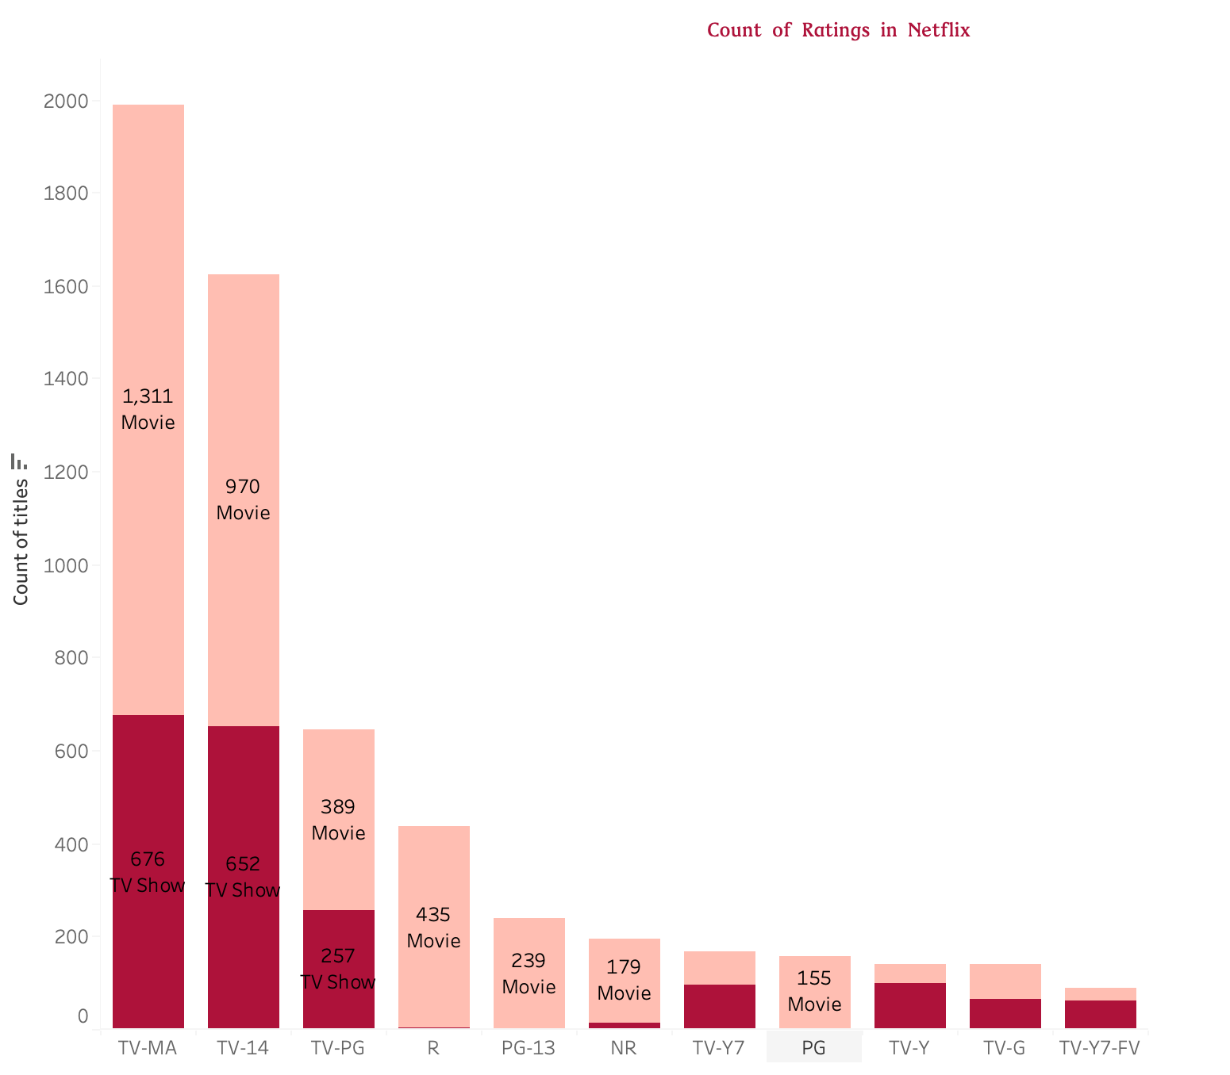

Fig 3. Ratings in Netflix

**Top Countries with Content**

From fig.4, it indicates the United States leads in content provision with 1,717 titles, followed by India with 702 titles, and the United Kingdom with 326 titles.

* This distribution underscores Netflix’s strategy to bolster its presence in key markets with substantial English-speaking populations and to tap into the large and diverse Indian market, reflecting both a local and global content strategy.
* This strategic approach not only caters to local preferences but also brings a rich variety of cultural content to a global audience, supporting Netflix's aim to be an international entertainment hub.

Fig. 4 Top Countries with Content

**Content Rating Trends**

From Fig.5 visualization indicates a dynamic shift in content ratings over time on Netflix. It shows a marked increase in TV-MA and TV-14 rated titles, particularly noticeable in the years leading up to and including 2019.

* The number of TV-MA rated titles rose sharply to a peak, while TV-14 rated content also saw a significant increase, reflecting a trend towards more mature content.
* This suggests an alignment with adult viewership and a response to demand for more sophisticated, adult-oriented programming.

Fig.5 Content Rating Trends

**Business Insights Recommendations:**

Based on the comprehensive analysis of Netflix's content data, the following recommendations are proposed:

* 1. **Content Length Customization:** With the insight that movie durations vary by genre, Netflix is advised to curate content lengths tailored to audience watching habits, offering both quick-bite experiences and longer, immersive narratives to suit different viewing preferences.
  2. **Strategic Global Expansion:** The data indicates a strong presence in specific markets, especially the U.S. and India. It's recommended to enhance regional content in other potential growth markets, using data-driven insights to cater to local tastes and cultural nuances.
  3. **Target Mature Audiences:** The increasing trend of TV-MA and TV-14 content consumption suggests that adult audiences are a key demographic. Netflix should continue to invest in and promote content that resonates with this segment while maintaining a balance with family-friendly options.
  4. **Casting Analytics:** Given the popularity of certain actors across multiple shows, Netflix should consider these analytics for casting decisions, potentially driving viewership through star power.
  5. **Adaptive Content Rating Strategy:** Observing the shifts in content rating preferences over the years, Netflix should remain agile, adjusting its content strategy to meet the evolving demands of its audience.

By implementing these recommendations, Netflix can further personalize its user experience, solidify its market dominance, and expand its global footprint.

**Unexpected Findings:**

The analysis of Netflix data revealed several unexpected findings:

1. **2019 Content Surge:** The significant increase in movies added to Netflix in 2019 may reflect a strategic acquisition spree or a push to expand the catalog to attract a wider audience. This could be due to market pressure or a pivot in content strategy to include more diverse or exclusive titles.
2. **Documentary Dominance:** The unexpected high volume of documentaries suggests that Netflix has identified and catered to a strong viewer interest in factual programming, which may also align with global trends in educational and informative content consumption.
3. **Mature Audience Focus:** The predominance of TV-MA and TV-14 content indicates that Netflix's content strategy is possibly geared more towards adults, which could be a response to demographic analytics that show a higher engagement rate in these age groups.
4. **Indian Content Representation:** The substantial representation of Indian content underlines Netflix's efforts to diversify its library with non-Western programming, catering to a growing subscriber base in India and those interested in Indian culture globally.
5. **Casting Patterns:** Notable actors appearing across multiple shows suggest that Netflix might be leveraging star power to draw viewers, indicating a strategy that banks on the popularity of these individuals to drive content success.
6. **Geographic Content Imbalance:** The U.S.-centric content library, despite Netflix's international user base, points to a potential strategy of relying on American content for global distribution or a lag in localizing content offerings in other regions.